Final Project Report – OOVP

Fazil Pradipta Helaw (00120240090)

IT4

**Whole App**

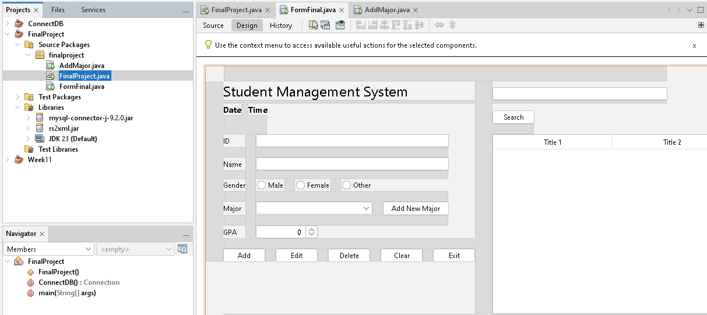

This application use 2 other libraries (mysql-connector-j-9.2.0.jar & rs2xml.jar). FinalProject.java used to store Connection function for database.

**Main App**

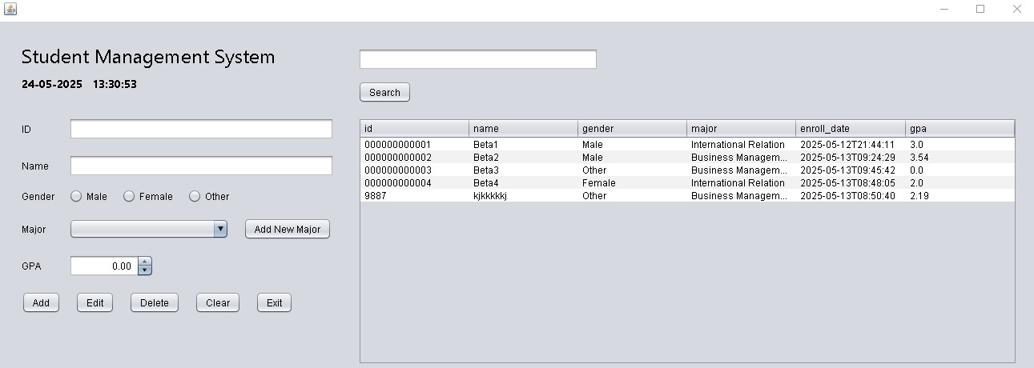

This is the main app for Student Management system where user can:

* View all students data from database
* Search specific students from database
* Insert new student data (ID, Name, Gender, Major, and GPA)
* Update student data that selected from the table (ID, Name, Gender, Major, and GPA)
* Delete student data that selected from the table (ID, Name, Gender, Major, and GPA)
* Enroll date is automatically insert with current time when user insert new data
* This app also show current time
* Open Add New Major App
* Clear/empty all input
* Exit the application

**Add Major App**

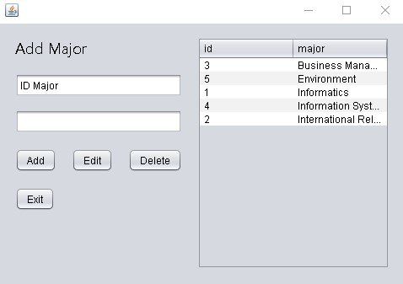

This is the add major app for Student Management system where user can:

* View all major in the database
* Insert new major data
* Update major data that selected from the table
* Id cannot be change and automatically filled with auto increment when new major is inserted
* Delete id and major data that selected from the table
* Exit button take the user back to the main app when pressed